**Assignment No. 8**

**Aggregate Functions**

1. Retrieve table employees and departments from hr schema.

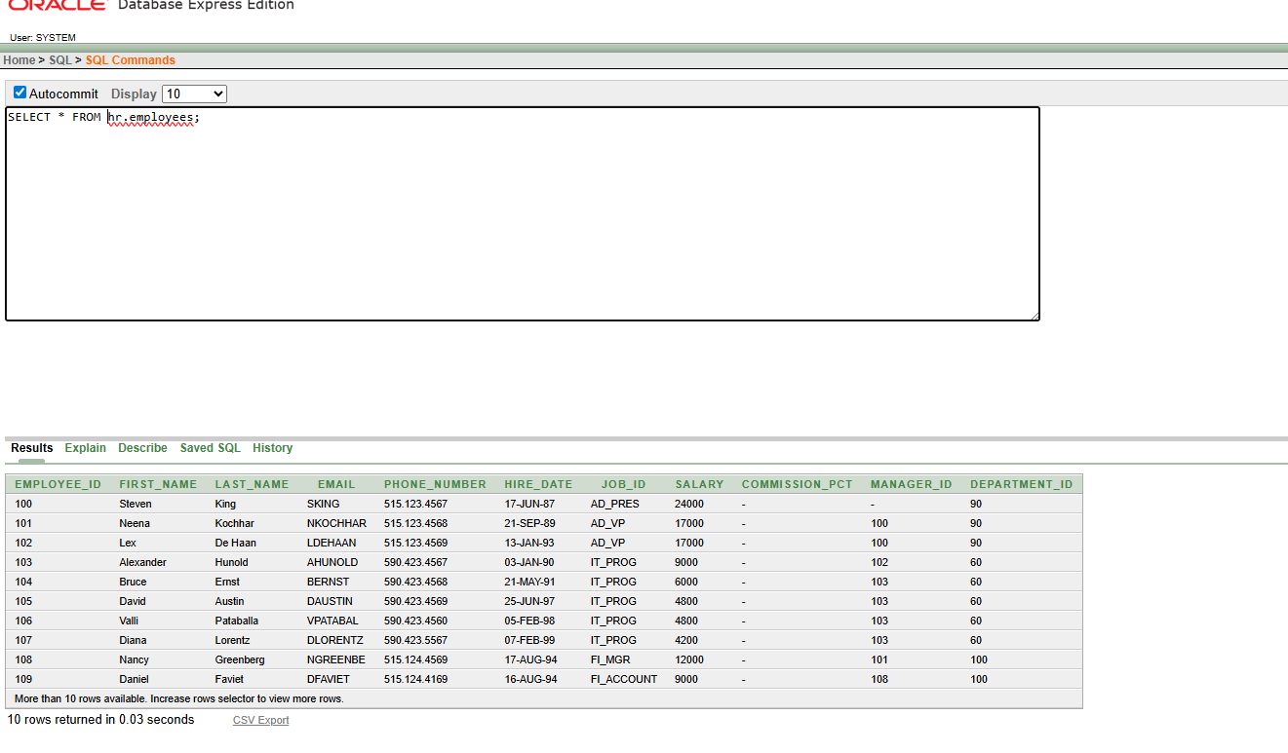

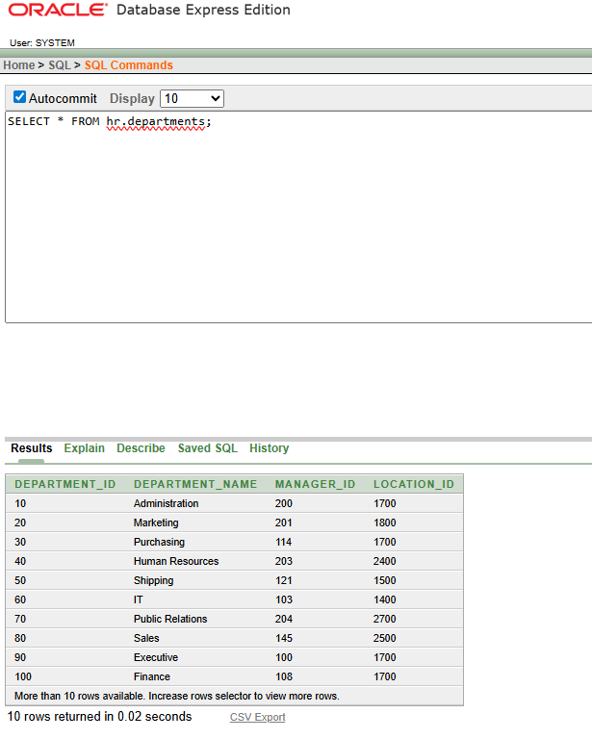

1. Find Minimum, maximum, average and sum of the salary of employees table..

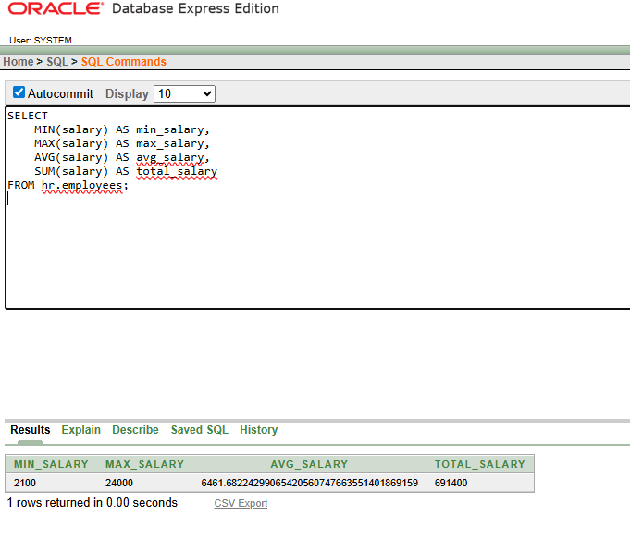

1. Find smallest department id from departments table.

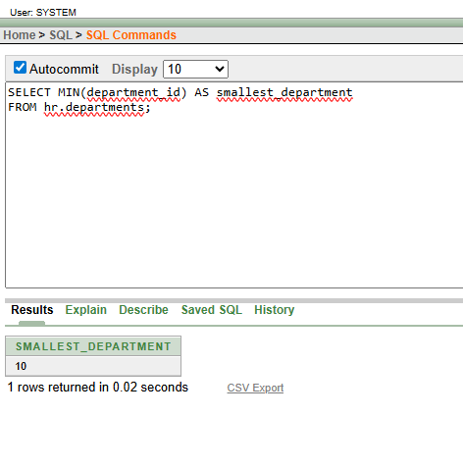

1. Find total number of records available in departments table.

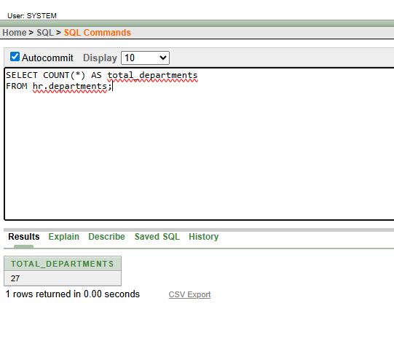

1. Find average salary of each department.

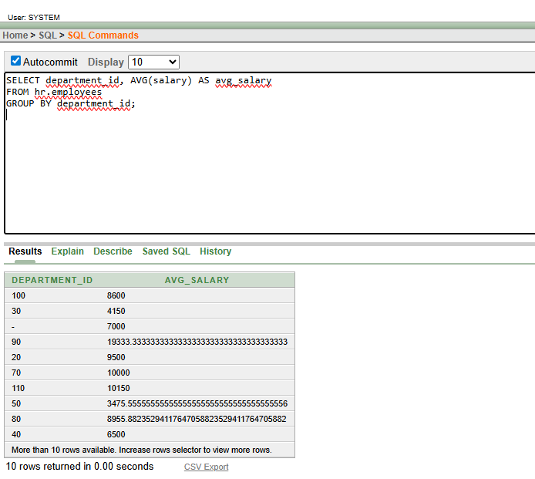

1. Count number of employees working in each department.

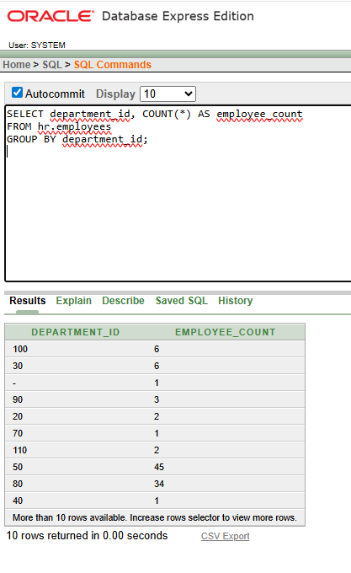

1. Find sum of salary of each department.

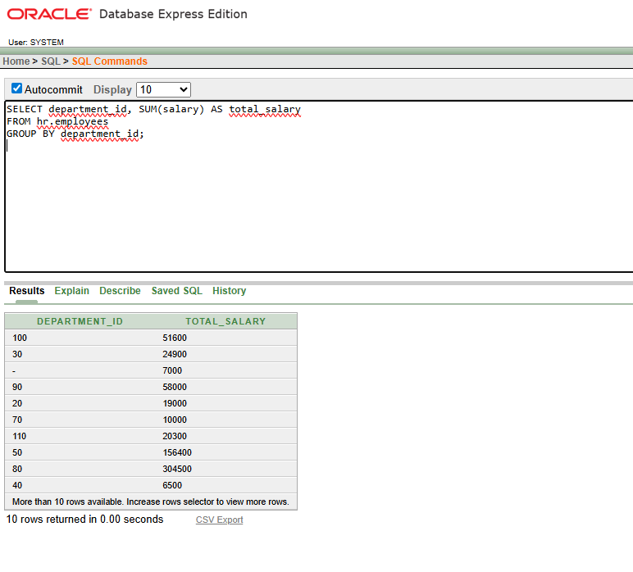

1. Find minumum and maximum salary for each department.

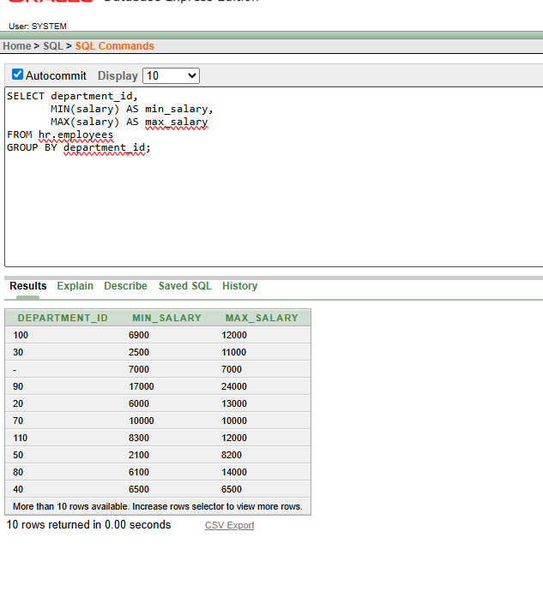

1. Display average salary for each job_id in Descending order of their average salary.

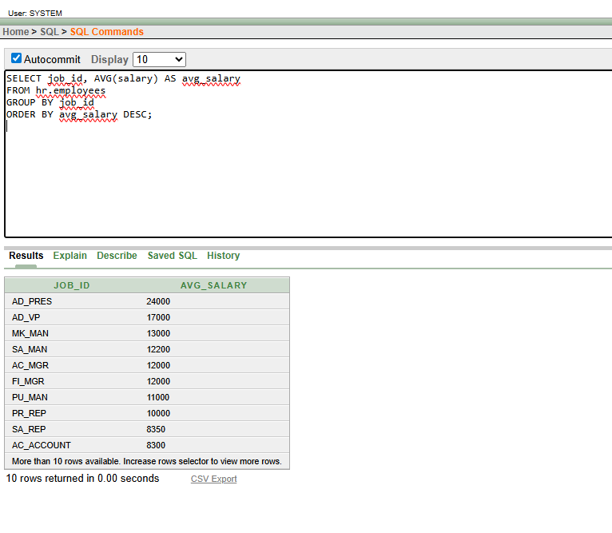

1. Find minimum and maximum salary for each job_id in alphabetical order of their JOB_id.

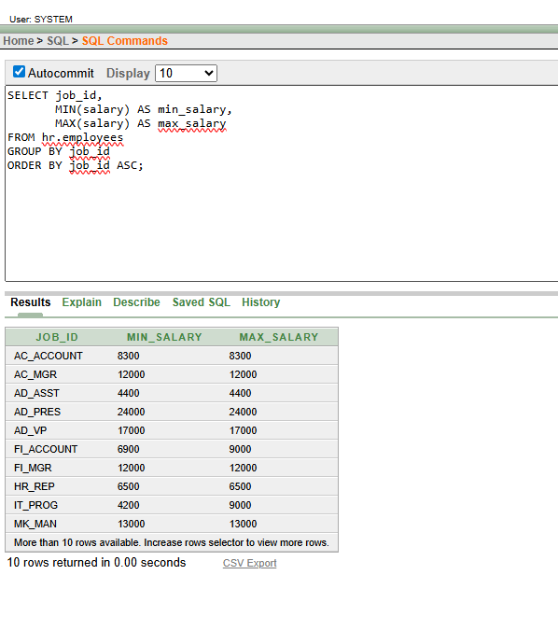

1. Display department id and respective average salaries for those departments whose maximum salary is greater than 10000.

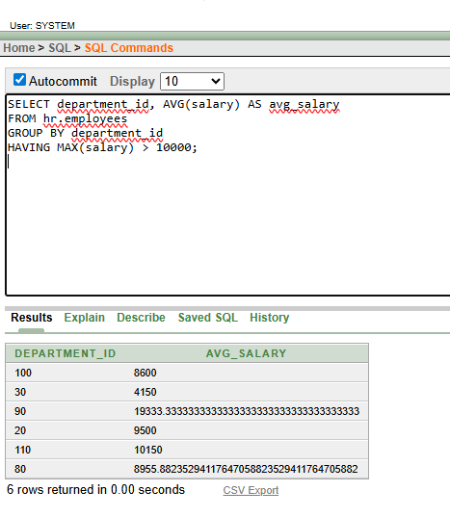

1. Display the minimum average salary.

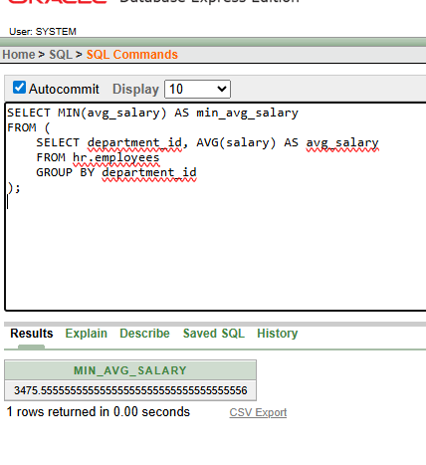

1. Write a query to display the number of people with the same job.

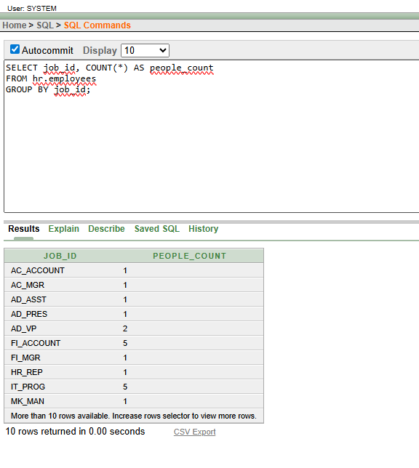

1. Find number of managers without listing them.

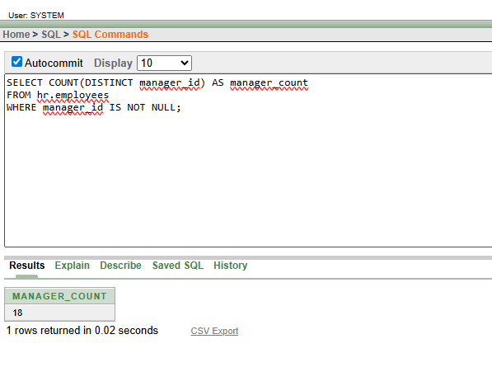

1. Write a query to display the difference between maximum and minimum salary of the table. Label the result column as **Difference.**

